|  |  |
| --- | --- |
| **NAME** | **SABARISHWARAN G** |
| **REG NO** | **713319EC512** |

**Circuit Diagram:**

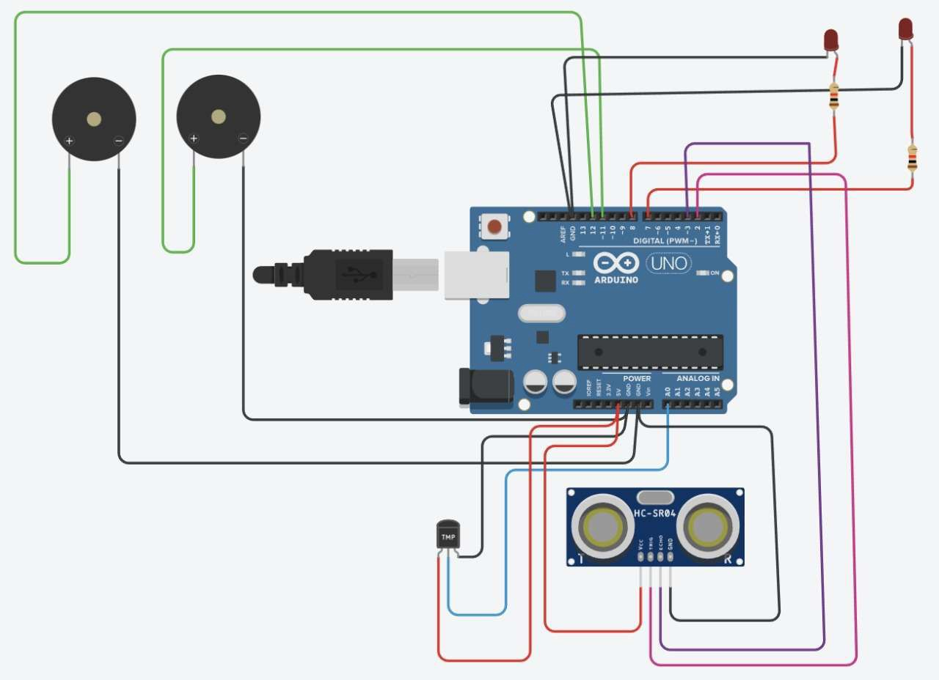

**Code:**

// C++ code int t=2;

int e=3; void setup()

{

Serial.begin(9600); pinMode(t,OUTPUT); pinMode(e,INPUT); pinMode(12,OUTPUT);

}

void loop()

{

//ultrasonic sensor digitalWrite(t,LOW); digitalWrite(t,HIGH); delayMicroseconds(10); digitalWrite(t,LOW);

float dur=pulseIn(e,HIGH); float dis=(dur*0.0343)/2; Serial.print("Distance is: "); Serial.println(dis);

//LED ON

if(dis>=60) //(in terms of centimeter)

{

digitalWrite(8,HIGH); digitalWrite(7,HIGH);

}

//Buzzer For ultrasonic Sensor if(dis>=60)

{

for(int i=0; i<=5; i=i+1)

{

tone(12,i); delay(1000); noTone(12); delay(1000);

}

}

//Temperate Sensor double a= analogRead(A0);

double t=(((a/1024)*5)-0.5)*100; Serial.print("Temp Value: "); Serial.println(t);

delay(1000);

//LED ON

if(t>=20) //(in terms of celsius)

{

digitalWrite(8,HIGH); digitalWrite(7,HIGH);

}

//Buzzer for Temperature Sensor if(t>=20)

{

for(int i=0; i<=5; i=i+1)

{

tone(12,i); delay(1000); noTone(12); delay(1000);

}

}

//LED OFF

if(t<20)

{

digitalWrite(8, LOW); digitalWrite(7, LOW);

}

}

**Output Serial Monitor:**

